Evan Agovino / Haiteng Xu / Xiang Wang Department of Statistics Eberly College of Science

Penn State University

December 14, 2015



1. **Introduction**

Today we are going to be doing a study of marketing data for a charitable organization. This organization wants to develop a data-mining model to improve the cost-effectiveness of their direct marketing campaigns to their donors. Recent mailing records show a typical overall response rate of 10%, an average donation of $14.50 and a cost of $2 per mailing. Because the expected profit for each mailing is $14.50*10% - $2 = -$0.55, it is not cost effective to mail everyone.

Thus, we want to develop a classification model using our data to capture our most likely donors and maximize expected net profit. We would also like to build a prediction model to predict donation amounts for donors, using data from only our customers who have previously donated. The entire dataset consists of 3,984 training observations, 2,018 validation observations and 2,007 test observations. The responders have been over-represented in the training and validation observations so that responders are closer to 50% of the data instead of the typical 10%.

1. **Exploratory Data Analysis**

**Removing Extraneous Variables**

First, let’s comb through the data to see if there are any predictors we need to transform or remove from our analysis. There are twenty total predictor variables and two response variables: DONR for our classification model and DAMT for our regression model.

The variables INCM (Median Family Income), INCA (Average Family Income) and PLOW (Neighborhood Low Income %) are all strongly correlated with each other and AVHV (Average Home Value). For this reason, we will remove them from both models. The TGIF variable ($ amount of lifetime gifts to date) is strongly correlated with NPRO (Lifetime # of Promotions Received), so we will remove it from both models. The LGIF ($ amount of largest gift to date) and AGIF (average $ amount of gifts to date) variables strongly correlate with RGIF ($ amount of recent gift), so we will remove them from both models.

**Transformations**

Next, we find that the AVHV (Average Home Value), RGIF ($ amount of Recent Gift) and TLAG (# of months between first and second gift) variables are skewed to the right. We will log-transform these so they are normally distributed (see **Exhibit 3** and **Exhibit 4** for histograms of these variables before and after the log transformation). We will also add **HINC2** to the model as we find that the profit with it included is generally higher than the profit without it for most of our classification models. Now we have 15 total predictor variables, after removing six and adding one.

1. **Models**

First we would like to define some common steps taken for all the models.

1. Develop a classification model for the DONR variable using other variables as predictors (except ID and DAMT). Fit all candidate models using the 3984 training observations and evaluate the fitted models using 2018 validation observations.
2. Then we will use “maximum profit” as the evaluation criteria to select the final classification model to classify DONR responses in the test dataset. The calculation of “maximum profit” as follows

* Calculate the posterior probabilities for the validation dataset;
* Sort DONR in order of the posterior probabilities from highest to lowest;
* Calculate the cumulative sum of (14.5 * DONR – 2);
* Then find the maximum of this profit function.

1. Develop a prediction model for the DAMT variable using other variables as predictors (except ID and DONR). We will use only the data records for which DONR=1. Fit all candidate models using the 3984 training observations and evaluate the fitted models using the 2018 validation observations.
2. Then we will use “mean prediction error” as the evaluation criteria to select the final prediction model to predict DAMT responses in the test dataset.

mean prediction error = mean((valid.y-pred.value)^2)

std error = sd((valid.y-pred.value)^2)/sqrt(n.valid.y)

1. **Classification Models**

**Classification Model 1 – Linear Discriminant Analysis**

|  |  |  |  |  |
| --- | --- | --- | --- | --- |
|  | Validation Leads | | | |
| LDA  Predictions |  | 0 | 1 |  |
| 0 | 661 | 12 | 673 |
| 1 | 358 | 987 | 1345 |
|  | 1019 | 999 | 2018 |

Number of Predicted Donors: 1345

Number of Correctly Predicted Donors: 987

Profit: ($14.5 * 987) – ($2 * 1345) = **$11,621.50**

**Classification Model 2 – Logistic Regression**

|  |  |  |  |  |
| --- | --- | --- | --- | --- |
|  | Validation Leads | | | |
| Logistic  Regression  Predictions |  | 0 | 1 |  |
| 0 | 724 | 21 | 745 |
| 1 | 295 | 978 | 1273 |
|  | 1019 | 999 | 2018 |

Number of Predicted Donors: 1273

Number of Correctly Predicted Donors: 978

Profit: ($14.5 * 978) – ($2 * 1273) = **$11,635.00**

**Classification Model 3 – Quadratic Discriminant Analysis**

|  |  |  |  |  |
| --- | --- | --- | --- | --- |
|  | Validation Leads | | | |
| QDA  Predictions |  | 0 | 1 |  |
| 0 | 593 | 34 | 627 |
| 1 | 426 | 965 | 1391 |
|  | 1019 | 999 | 2018 |

Number of Predicted Donors: 1391

Number of Correctly Predicted Donors: 965

Profit: ($14.5 * 965) – ($2 * 1391) = **$11,210.50**

**Classification Model 4 – K-Nearest Neighbors**

This was modeled using all twenty predictors

K=29 (found via Leave-One-Out Cross Validation)

*(We are unable to see the results of leads versus predictions, just the final result)*

Number of Predicted Donors: 1305

Number of Correctly Predicted Donors: 953

Profit: ($14.5 * 953) – ($2 * 1305) = **$11,208.50**

**Classification Model 5 – Generalized Additive Model**

This was modeled using all twenty predictors**.** The predictors determined to be non-significant (GENF, LGIF, RGIF, AGIF) were removed.

Each ordinal and quantitative predictor was modeled using a smoothing spline with five degrees of freedom.

|  |  |  |  |  |
| --- | --- | --- | --- | --- |
|  | Validation Leads | | | |
| GAM  Predictions |  | 0 | 1 |  |
| 0 | 776 | 5 | 781 |
| 1 | 243 | 994 | 1237 |
|  | 1019 | 999 | 2018 |

Number of Predicted Donors: 1237

Number of Correctly Predicted Donors: 994

Profit: ($14.5 * 994) – ($2 * 1237) = **$11,939.00**

**Classification Model 6 – Regression Tree**

This was modeled using all twenty predictorsplus the squared value of the “HINC” predictor.

|  |  |  |  |  |
| --- | --- | --- | --- | --- |
|  | Validation Leads | | | |
| Regression  Tree  Predictions |  | 0 | 1 |  |
| 0 | 645 | 37 | 692 |
| 1 | 374 | 962 | 1336 |
|  | 1019 | 999 | 2018 |

Number of Predicted Donors: 1336

Number of Correctly Predicted Donors: 962

Profit: ($14.5 * 962) – ($2 * 1336) = **$11,277.00**

**Classification Model 7 – Random Forest**

We found that the random forest model with fifteen variables performed better than the model with all twenty predictors plus the squared value of the “HINC” predictor.

|  |  |  |  |  |
| --- | --- | --- | --- | --- |
|  | Validation Leads | | | |
| Random  Forest  Predictions |  | 0 | 1 |  |
| 0 | 750 | 12 | 762 |
| 1 | 269 | 987 | 1256 |
|  | 1019 | 999 | 2018 |

Number of Predicted Donors: 1256

Number of Correctly Predicted Donors: 987

Profit: ($14.5 * 987) – ($2 * 1256) = **$11,799.50**

**Classification Model 8 – Support Vector Machine**

This was modeled using all twenty predictorsplus the squared value of the “HINC” predictor.

|  |  |  |  |  |
| --- | --- | --- | --- | --- |
|  | Validation Leads | | | |
| Random  Forest  Predictions |  | 0 | 1 |  |
| 0 | 686 | 18 | 704 |
| 1 | 333 | 981 | 1314 |
|  | 1019 | 999 | 2018 |

Number of Predicted Donors: 1314

Number of Correctly Predicted Donors: 981

Profit: ($14.5 * 981) – ($2 * 1314) = **$11,596.50**

1. **Prediction Models**

**Prediction Model 1 – Least Squares Regression**

We begin with our fifteen predictors and drop REG1, REG2, WRAT and TLAG from the model as they are not significant.

**Mean Prediction Error: 1.880**

**Standard Deviation: 0.169**

**Prediction Model 2 – Stepwise Regression Using AIC**

The model with the smallest AIC found via stepwise regression ends up having the same predictors as our first model with REG2 added.

**Mean Prediction Error: 1.872**

**Standard Deviation: 0.169**

**Prediction Model 3 – Best Subset Selection Using BIC**

The eight-variable model with REG3, REG4, HOME, CHLD, HINC, NPRO, RGIF and TDON has the lowest BIC value.

**Mean Prediction Error: 1.895**

**Standard Deviation: 0.170**

**Prediction Model 4 – Ridge Regression**

Λ = 0.787 (found via 10-fold cross validation: See **Exhibit 5**)

**Mean Prediction Error: 1.836**

**Standard Deviation: 0.173**

**Prediction Model 5 – Lasso Regression (with 10-Fold Cross Validation)**

Λ = 0.099 (found via 10-fold cross validation: See **Exhibit 6**)

**Mean Prediction Error: 1.819**

**Standard Deviation: 0.164**

**Prediction Model 6 – Principal Components Regression**

The lowest cross-validation error occurs when 15 components are used. Even though the CV error only reduces slightly when less components are used, we find that the 15 component model has the lowest CV error.

**Mean Prediction Error: 1.870**

**Standard Deviation: 0.169**

**Prediction Model 7 – Partial Least Squares**

The lowest cross-validation error occurs when 5 components are used.

**Mean Prediction Error: 1.873**

**Standard Deviation: 0.169**

1. **Summary Results**

**Classification Model Results:**

|  |  |  |
| --- | --- | --- |
| **Number of Predicted Donors** | **Profit** | **Model** |
| 1345 | $11,621.50 | Linear Discriminant Analysis |
| 1273 | $11,635.00 | Logistic Regression |
| 1391 | $11,210.50 | Quadratic Discriminant Analysis |
| 1305 | $11,208.50 | K-Nearest Neighbors |
| **1237** | **$11,939.00** | **Generalized Additive Model** |
| 1391 | $11,312.00 | Regression Tree |
| 1314 | $11,799.50 | Random Forest |
| 1314 | $11,596.50 | Support Vector Machine |

The success of the linear discriminant analysis and logistic regression models relative to the quadratic discriminant analysis shows that the observations within each class are something close to uncorrelated random normal variables, which is to be expected after we removed the correlated variables and transformed the skewed variables. Since there only two response categories, donor (1) or non-donor (0), the logistic regression performs better than the LDA model (although only slightly).

Still, the generalized additive model and random forest are superior to linear discriminant analysis and logistic regression. The generalized additive model may be the most superior because it allows us to automatically model non-linear relationships, meaning that we don’t need to worry about whether the transformations we made impacted the model. This helps when there are over a dozen predictors we can transform! From the earlier data analysis we could tell that some predictors had non-linear relationship with the response, so GAM’s non-linear fits can potentially make more accurate predictions for the response *Y.* And this is the case here, GAM model gives the most predictive power.

**Prediction Model Results:**

|  |  |  |
| --- | --- | --- |
| Mean Prediction Error | Standard Deviation | Model |
| 1.880 | 0.169 | Least Squares Regression |
| 1.872 | 0.169 | Stepwise Regression (AIC) |
| 1.895 | 0.170 | Best Subset Selection (BIC) |
| 1.832 | 0.173 | Ridge Regression |
| **1.819** | **0.164** | **Lasso** |
| 1.870 | 0.169 | Principal Components Regression |
| 1.873 | 0.169 | Partial Least Sqaures |

We can see that the ridge regression and lasso model perform better than the least squares models. This could mean that the least squares estimates have high variance. We also see that the lasso performs better than the ridge regression, meaning that there are some extraneous predictors that the lasso model removed. There were only 10 predictors in the lasso regression as opposed to the twenty in ridge regression. If the response was a function of more predictors, the ridge regression would have performed better.

1. **Conclusion**

Based on maximum profit, the **generalized additive model** scores the best as it nets us a profit of $11,939.00 on the validation data.

Based on mean prediction error, the **lasso model** scores the best as it gives us a mean prediction error of **1.819**.

**Appendix**

**Exhibit 1:**

**List of Variables (variables eliminated from the model are *italicized*):**

|  |  |  |
| --- | --- | --- |
| ID | Customer # - Not a predictor variable | Ordinal |
| REG1/REG2  /REG3/REG4 | Region (Five Regions Total) | Binary (0 for all four responses means customer is in Reg 5) |
| HOME | Homeowner | Binary |
| CHLD | Number of Children | Ordinal |
| HINC | Household Income | Ordinal |
| GENF | Gender | Binary |
| WRAT | Wealth Rating | Ordinal |
| AVHV | Average Home Value | Quantitative |
| *INCM* | *Median Family Income* | *Quantitative* |
| *INCA* | *Average Family Income* | *Quantitative* |
| *PLOW* | *Neighborhood Low Income %* | *Quantitative* |
| NPRO | Lifetime Number of Promotions Received | Quantitative |
| *TGIF* | *$ amount of lifetime gifts to date* | *Quantitative* |
| *LGIF* | *$ amount of largest gift to date* | *Quantitative* |
| RGIF | $ amount of most recent gift | Quantitative |
| TDON | # of Months since Last Donation | Quantitative |
| TLAG | # of months between first and second gift | Quantitative |
| *AGIF* | *Average $ amount of gifts to date* | *Quantitative* |
| DONR | RESPONSE VARIABLE: (Donor) | Binary |
| DAMT | RESPONSE VARIABLE: (Predicted Donation Amount) | Quantitative |

**Exhibit 2:**

**Scatterplots of Predictors**

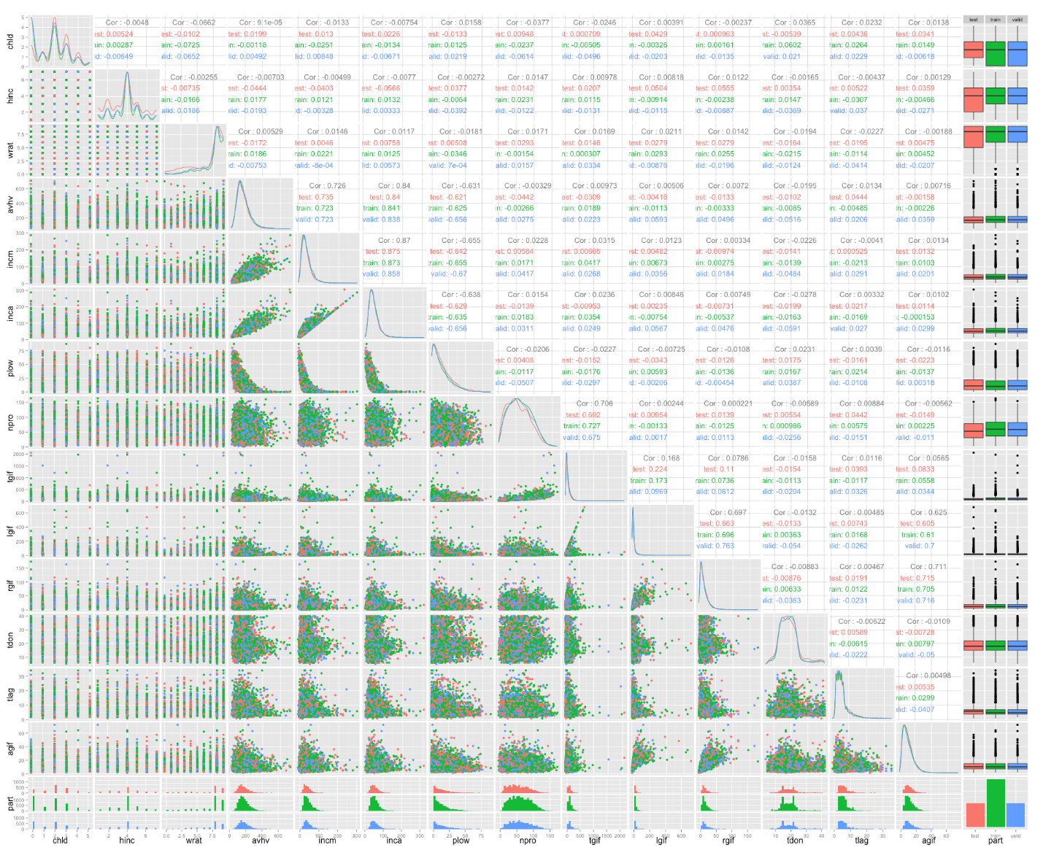

**Exhibit 3**:

**Histograms of AVHV, RGIF and TLAG Variables (Before Log Transformation)**

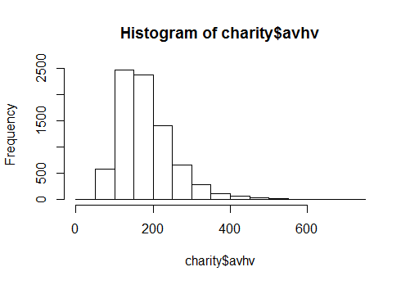

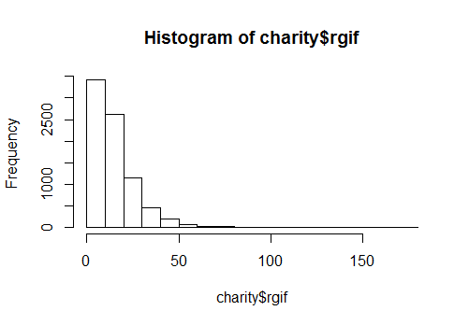

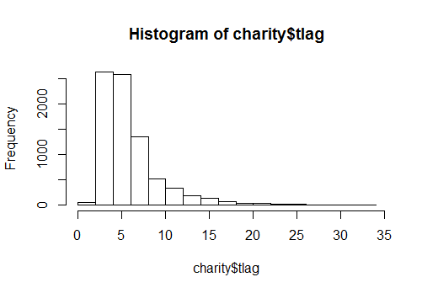

**Exhibit 4:**

**Histograms of AVHV, RGIF and TLAG Variables (After Log Transformation)**

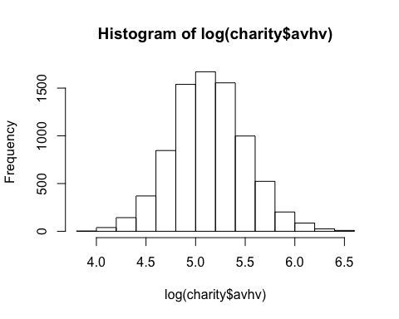

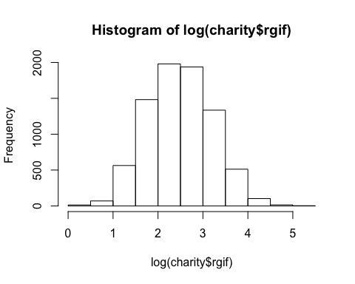

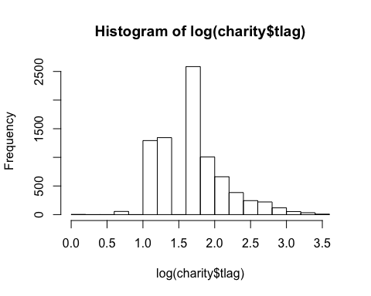

**Exhibit 5:**

**Lambda Plot for Ridge Regression Model**

(Note the 20s on top of the graph mean that the ridge regression model will always have twenty predictors)

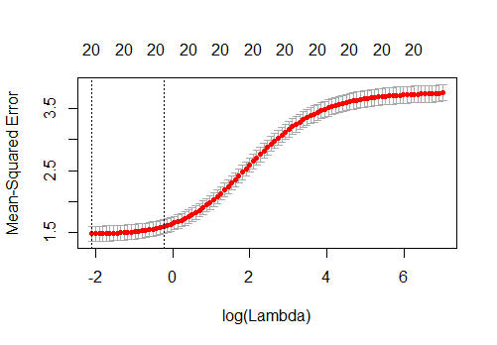

**Exhibit 6:**

**Lambda Plot for Lasso Model**

(Note the numbers between one and twenty on top of the graph mean that the ridge regression model will always have twenty predictors)



**R Code and some output**

### Exploratory Data Analysis

charity <- read.csv("charity.csv")

charity1 <- charity[, c(7:8, 10:21, 24)]   
## Matrix scatter plot using ggpairs()   
library(GGally); # ggpairs(charity1, colour='part')   
hist(log(charity$avhv))

hist(log(charity$rgif))

hist(log(charity$tlag))

# transformations  
charity.t <- charity  
charity.t$avhv <- log(charity.t$avhv)   
charity.t$rgif <- log(charity.t$rgif)  
charity.t$tlag <- log(charity.t$tlag)  
  
# set up data for analysis  
data.train <- charity.t[charity$part=="train",]  
x.train <- data.train[,2:21]  
c.train <- data.train[,22] # donr  
n.train.c <- length(c.train) # 3984  
y.train <- data.train[c.train==1,23] # damt for observations with donr=1  
n.train.y <- length(y.train) # 1995  
  
data.valid <- charity.t[charity$part=="valid",]  
x.valid <- data.valid[,2:21]  
c.valid <- data.valid[,22] # donr  
n.valid.c <- length(c.valid) # 2018  
y.valid <- data.valid[c.valid==1,23] # damt for observations with donr=1  
n.valid.y <- length(y.valid) # 999  
  
data.test <- charity.t[charity$part=="test",]  
n.test <- dim(data.test)[1] # 2007  
x.test <- data.test[,2:21]  
  
x.train.mean <- apply(x.train, 2, mean)  
x.train.sd <- apply(x.train, 2, sd)  
x.train.std <- t((t(x.train)-x.train.mean)/x.train.sd) # standardize to have zero mean and unit sd  
apply(x.train.std, 2, mean) # check zero mean

apply(x.train.std, 2, sd) # check unit sd

data.train.std.c <- data.frame(x.train.std, donr=c.train) # to classify donr  
data.train.std.y <- data.frame(x.train.std[c.train==1,], damt=y.train) # to predict damt when donr=1  
  
x.valid.std <- t((t(x.valid)-x.train.mean)/x.train.sd) # standardize using training mean and sd  
data.valid.std.c <- data.frame(x.valid.std, donr=c.valid) # to classify donr  
data.valid.std.y <- data.frame(x.valid.std[c.valid==1,], damt=y.valid) # to predict damt when donr=1  
  
x.test.std <- t((t(x.test)-x.train.mean)/x.train.sd) # standardize using training mean and sd  
data.test.std <- data.frame(x.test.std)

### 

### Classification modeling

#### 

#### Model 1: linear discriminant analysis (LDA)

library(MASS)  
model.lda <- lda(donr ~ reg1 + reg2 + reg3 + reg4 + home + chld + hinc + I(hinc^2) + genf + wrat + avhv + npro + rgif + tdon + tlag, data.train.std.c) # include additional terms on the fly using I()  
# Note: strictly speaking, LDA should not be used with qualitative predictors, but in practice it often is if the goal is simply to find a good predictive model  
post.valid.lda <- predict(model.lda, data.valid.std.c)$posterior[,2] # n.valid.c post probs  
# calculate ordered profit function using average donation = $14.50 and mailing cost = $2  
profit.lda <- cumsum(14.5*c.valid[order(post.valid.lda, decreasing=T)]-2)  
plot(profit.lda) # see how profits change as more mailings are made

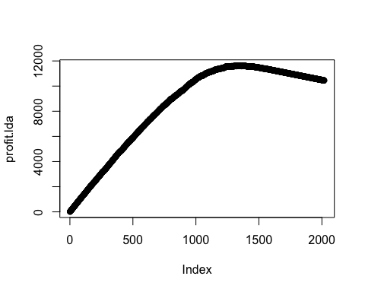

n.mail.valid <- which.max(profit.lda) # number of mailings that maximizes profits  
c(n.mail.valid, max(profit.lda)) # report number of mailings and maximum profit; 1345, 11621.5

## [1] 1345.0 11621.5

cutoff.lda <- sort(post.valid.lda, decreasing=T)[n.mail.valid+1] # set cutoff based on n.mail.valid  
chat.valid.lda <- ifelse(post.valid.lda > cutoff.lda, 1, 0) # mail to everyone above the cutoff  
table(chat.valid.lda, c.valid) # classification table

# c.valid  
#chat.valid.lda 0 1  
# 0 661 12  
# 1 358 987  
# check n.mail.valid = 358+987 = 1345  
# check profit = 14.5*987-2*1345 = 11621.5

#### 

#### Model 2: logistic regression (LR)

model.log <- glm(donr ~ reg1 + reg2 + reg3 + reg4 + home + chld + hinc + I(hinc^2) + genf + wrat + avhv + npro + rgif + tdon + tlag, data.train.std.c, family=binomial("logit"))  
post.valid.log <- predict(model.log, data.valid.std.c, type="response") # n.valid post probs  
  
# calculate ordered profit function using average donation = $14.50 and mailing cost = $2  
profit.log <- cumsum(14.5*c.valid[order(post.valid.log, decreasing=T)]-2)  
plot(profit.log) # see how profits change as more mailings are made

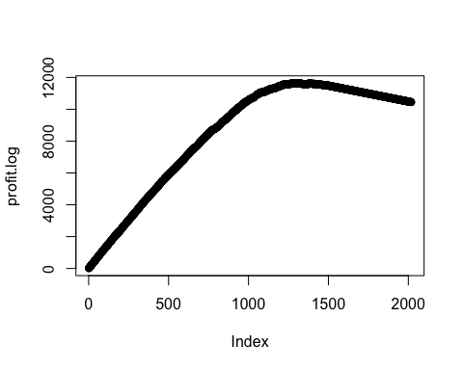

n.mail.valid <- which.max(profit.log) # number of mailings that maximizes profits  
c(n.mail.valid, max(profit.log)) # report number of mailings and maximum profit; 1273, 11635

## [1] 1273 11635

cutoff.log <- sort(post.valid.log, decreasing=T)[n.mail.valid+1] # set cutoff based on n.mail.valid  
chat.valid.log <- ifelse(post.valid.log > cutoff.log, 1, 0) # mail to everyone above the cutoff  
table(chat.valid.log, c.valid) # classification table

# c.valid  
#chat.valid.log 0 1  
# 0 724 21  
# 1 295 978  
# check n.mail.valid = 295+978 = 1273  
# check profit = 14.5*978-2*1273 = 11635

#### 

#### Model 3: Quadratic discriminant analysis (QDA)

model.qda <- qda(donr ~ reg1 + reg2 + reg3 + reg4 + home + chld + hinc + I(hinc^2) + genf + wrat + avhv + npro + rgif + tdon + tlag, data.train.std.c)   
post.valid.qda <- predict(model.qda, data.valid.std.c)$posterior[,2] # n.valid.c post probs  
# calculate ordered profit function using average donation = $14.50 and mailing cost = $2  
profit.qda <- cumsum(14.5*c.valid[order(post.valid.qda, decreasing=T)]-2)  
plot(profit.qda) # see how profits change as more mailings are made

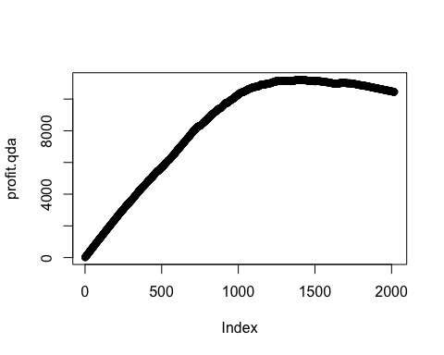

n.mail.valid <- which.max(profit.qda) # number of mailings that maximizes profits  
c(n.mail.valid, max(profit.qda)) # report number of mailings and maximum profit

## [1] 1391.0 11210.5  
  
cutoff.qda <- sort(post.valid.qda, decreasing=T)[n.mail.valid+1] # set cutoff based on n.mail.valid  
chat.valid.qda <- ifelse(post.valid.qda>cutoff.qda, 1, 0) # mail to everyone above the cutoff  
table(chat.valid.qda, c.valid) # classification table

# c.valid  
#chat.valid.qda 0 1  
# 0 593 34  
# 1 426 965  
# check n.mail.valid = 426+965 = 1391  
# check profit = 14.5*965-2*1391 = 11210.5

#### 

#### Model 4: K-Nearest Neighbors (KNN)

library(class)  
mer <- rep(NA, 30) # misclassification error rates based on leave-one-out cross-validation  
set.seed(2014) # seed must be set because R randomly breaks ties  
for (i in 1:30) mer[i] <- sum((c.train-(c(knn.cv(train=x.train, cl=c.train, k=i))-1))^2)/n.train.c  
which.min(mer) # minimum occurs at k=29

set.seed(2014)  
post.valid.knn <- knn(data.train.std.c[,-21], data.valid.std.c[,-21], data.train.std.c[,21], k=29, prob=T)  
  
# calculate ordered profit function using average donation = $14.50 and mailing cost = $2  
profit.knn <- cumsum(14.5*c.valid[order(post.valid.knn, decreasing=T)]-2)  
plot(profit.knn) # see how profits change as more mailings are made

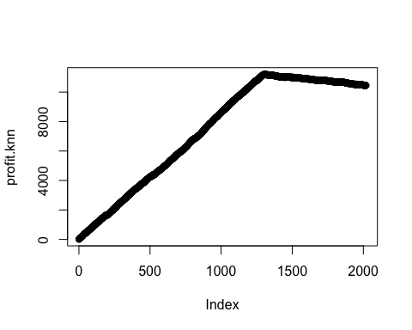

n.mail.valid <- which.max(profit.knn) # number of mailings that maximizes profits  
c(n.mail.valid, max(profit.knn)) # report number of mailings and maximum profit; 1305, 11208.5

## [1] 1305.0 11208.5

#### 

#### Model 5: Logistic regression generalized additive model (GAM) with each predictor modeled using a smoothing spline with 5 degrees of freedom

library(gam)

model.gam <- gam(donr ~ reg1 + reg2 + reg3 + reg4 + home + s(chld,df=5) + s(hinc,df=5) + genf + s(wrat,df=5) + s(avhv,df=5) + s(incm,df=5) + s(inca,df=5) + s(plow,df=5) + s(npro,df=5) + s(tgif,df=5) + s(lgif,df=5) + s(rgif,df=5) + s(tdon,df=5) + s(tlag,df=5) + s(agif,df=5), data.train.std.c, family=binomial)  
summary(model.gam)

##   
## Call: gam(formula = donr ~ reg1 + reg2 + reg3 + reg4 + home + s(chld,   
## df = 5) + s(hinc, df = 5) + genf + s(wrat, df = 5) + s(avhv,   
## df = 5) + s(incm, df = 5) + s(inca, df = 5) + s(plow, df = 5) +   
## s(npro, df = 5) + s(tgif, df = 5) + s(lgif, df = 5) + s(rgif,   
## df = 5) + s(tdon, df = 5) + s(tlag, df = 5) + s(agif, df = 5),   
## family = binomial, data = data.train.std.c)  
## Deviance Residuals:  
## Min 1Q Median 3Q Max   
## -3.154918 -0.130361 0.001612 0.238887 2.983810   
##   
## (Dispersion Parameter for binomial family taken to be 1)  
##   
## Null Deviance: 5522.988 on 3983 degrees of freedom  
## Residual Deviance: 1521.23 on 3907 degrees of freedom  
## AIC: 1675.231   
##   
## Number of Local Scoring Iterations: 11   
##   
## Anova for Parametric Effects  
## Df Sum Sq Mean Sq F value Pr(>F)   
## reg1 1 1.24 1.24 1.9512 0.16254   
## reg2 1 103.67 103.67 163.3938 < 2.2e-16 ***  
## reg3 1 0.96 0.96 1.5068 0.21970   
## reg4 1 0.01 0.01 0.0088 0.92535   
## home 1 54.45 54.45 85.8285 < 2.2e-16 ***  
## s(chld, df = 5) 1 788.22 788.22 1242.3511 < 2.2e-16 ***  
## s(hinc, df = 5) 1 0.01 0.01 0.0123 0.91174   
## genf 1 0.93 0.93 1.4585 0.22724   
## s(wrat, df = 5) 1 169.14 169.14 266.5948 < 2.2e-16 ***  
## s(avhv, df = 5) 1 61.24 61.24 96.5292 < 2.2e-16 ***  
## s(incm, df = 5) 1 43.79 43.79 69.0119 < 2.2e-16 ***  
## s(inca, df = 5) 1 1.90 1.90 2.9964 0.08353 .   
## s(plow, df = 5) 1 2.04 2.04 3.2103 0.07325 .   
## s(npro, df = 5) 1 71.01 71.01 111.9167 < 2.2e-16 ***  
## s(tgif, df = 5) 1 17.91 17.91 28.2284 1.138e-07 ***  
## s(lgif, df = 5) 1 2.88 2.88 4.5365 0.03324 *   
## s(rgif, df = 5) 1 0.62 0.62 0.9819 0.32178   
## s(tdon, df = 5) 1 22.72 22.72 35.8094 2.372e-09 ***  
## s(tlag, df = 5) 1 109.10 109.10 171.9609 < 2.2e-16 ***  
## s(agif, df = 5) 1 0.92 0.92 1.4492 0.22873   
## Residuals 3907 2478.82 0.63   
## ---  
## Signif. codes: 0 '***' 0.001 '**' 0.01 '*' 0.05 '.' 0.1 ' ' 1  
## Anova for Nonparametric Effects  
## Npar Df Npar Chisq P(Chi)   
## (Intercept)   
## reg1   
## reg2   
## reg3   
## reg4   
## home   
## s(chld, df = 5) 4 251.30 < 2.2e-16 ***  
## s(hinc, df = 5) 4 599.56 < 2.2e-16 ***  
## genf   
## s(wrat, df = 5) 4 75.22 1.776e-15 ***  
## s(avhv, df = 5) 4 6.30 0.177869   
## s(incm, df = 5) 4 29.25 6.941e-06 ***  
## s(inca, df = 5) 4 26.18 2.913e-05 ***  
## s(plow, df = 5) 4 16.63 0.002284 **   
## s(npro, df = 5) 4 7.75 0.101320   
## s(tgif, df = 5) 4 10.17 0.037640 *   
## s(lgif, df = 5) 4 5.75 0.218428   
## s(rgif, df = 5) 4 3.08 0.543850   
## s(tdon, df = 5) 4 143.14 < 2.2e-16 ***  
## s(tlag, df = 5) 4 36.78 1.997e-07 ***  
## s(agif, df = 5) 4 3.58 0.465298   
## ---  
## Signif. codes: 0 '***' 0.001 '**' 0.01 '*' 0.05 '.' 0.1 ' ' 1

#remove spline for linear predictors  
model.gam2 <- gam(donr ~ reg1 + reg2 + reg3 + reg4 + home + s(chld,df=5) + s(hinc,df=5) + genf + s(wrat,df=5) + avhv + s(incm,df=5) + s(inca,df=5) + s(plow,df=5) + npro + s(tgif,df=5) + lgif + rgif + s(tdon,df=5) + s(tlag,df=5) + agif, data.train.std.c, family=binomial)

summary(model.gam2)

##   
## Call: gam(formula = donr ~ reg1 + reg2 + reg3 + reg4 + home + s(chld,   
## df = 5) + s(hinc, df = 5) + genf + s(wrat, df = 5) + avhv +   
## s(incm, df = 5) + s(inca, df = 5) + s(plow, df = 5) + npro +   
## s(tgif, df = 5) + lgif + rgif + s(tdon, df = 5) + s(tlag,   
## df = 5) + agif, family = binomial, data = data.train.std.c)  
## Deviance Residuals:  
## Min 1Q Median 3Q Max   
## -3.142273 -0.131625 0.002241 0.240759 2.909445   
##   
## (Dispersion Parameter for binomial family taken to be 1)  
##   
## Null Deviance: 5522.988 on 3983 degrees of freedom  
## Residual Deviance: 1542.91 on 3926.999 degrees of freedom  
## AIC: 1656.912   
##   
## Number of Local Scoring Iterations: 10   
##   
## Anova for Parametric Effects  
## Df Sum Sq Mean Sq F value Pr(>F)   
## reg1 1 1.47 1.47 2.3158 0.12815   
## reg2 1 104.73 104.73 165.2480 < 2.2e-16 ***  
## reg3 1 0.99 0.99 1.5571 0.21216   
## reg4 1 0.00 0.00 0.0019 0.96487   
## home 1 53.03 53.03 83.6731 < 2.2e-16 ***  
## s(chld, df = 5) 1 780.09 780.09 1230.8992 < 2.2e-16 ***  
## s(hinc, df = 5) 1 0.01 0.01 0.0136 0.90733   
## genf 1 0.97 0.97 1.5232 0.21721   
## s(wrat, df = 5) 1 167.23 167.23 263.8786 < 2.2e-16 ***  
## avhv 1 57.87 57.87 91.3060 < 2.2e-16 ***  
## s(incm, df = 5) 1 41.81 41.81 65.9678 6.078e-16 ***  
## s(inca, df = 5) 1 0.73 0.73 1.1557 0.28243   
## s(plow, df = 5) 1 2.83 2.83 4.4686 0.03459 *   
## npro 1 68.96 68.96 108.8102 < 2.2e-16 ***  
## s(tgif, df = 5) 1 15.78 15.78 24.9056 6.282e-07 ***  
## lgif 1 0.76 0.76 1.1999 0.27342   
## rgif 1 0.23 0.23 0.3693 0.54341   
## s(tdon, df = 5) 1 20.38 20.38 32.1554 1.526e-08 ***  
## s(tlag, df = 5) 1 107.42 107.42 169.5032 < 2.2e-16 ***  
## agif 1 1.73 1.73 2.7276 0.09871 .   
## Residuals 3927 2488.75 0.63   
## ---  
## Signif. codes: 0 '***' 0.001 '**' 0.01 '*' 0.05 '.' 0.1 ' ' 1  
##   
## Anova for Nonparametric Effects  
## Npar Df Npar Chisq P(Chi)   
## (Intercept)   
## reg1   
## reg2   
## reg3   
## reg4   
## home   
## s(chld, df = 5) 4 252.77 < 2.2e-16 ***  
## s(hinc, df = 5) 4 590.91 < 2.2e-16 ***  
## genf   
## s(wrat, df = 5) 4 74.40 2.665e-15 ***  
## avhv   
## s(incm, df = 5) 4 25.72 3.599e-05 ***  
## s(inca, df = 5) 4 25.59 3.819e-05 ***  
## s(plow, df = 5) 4 18.02 0.001223 **   
## npro   
## s(tgif, df = 5) 4 12.14 0.016313 *   
## lgif   
## rgif   
## s(tdon, df = 5) 4 140.96 < 2.2e-16 ***  
## s(tlag, df = 5) 4 37.76 1.258e-07 ***  
## agif   
## ---  
## Signif. codes: 0 '***' 0.001 '**' 0.01 '*' 0.05 '.' 0.1 ' ' 1

#remove non-significant predictors  
model.gam3 <- gam(donr ~ reg1 + reg2 + reg3 + reg4 + home + s(chld,df=5) + s(hinc,df=5) + s(wrat,df=5) + avhv + s(incm,df=5) + s(inca,df=5) + s(plow,df=5) + npro + s(tgif,df=5) + s(tdon,df=5) + s(tlag,df=5), data.train.std.c, family=binomial)  
summary(model.gam3)

##   
## Call: gam(formula = donr ~ reg1 + reg2 + reg3 + reg4 + home + s(chld,   
## df = 5) + s(hinc, df = 5) + s(wrat, df = 5) + avhv + s(incm,   
## df = 5) + s(inca, df = 5) + s(plow, df = 5) + npro + s(tgif,   
## df = 5) + s(tdon, df = 5) + s(tlag, df = 5), family = binomial,   
## data = data.train.std.c)  
## Deviance Residuals:  
## Min 1Q Median 3Q Max   
## -3.154742 -0.132956 0.002474 0.240161 2.854841   
##   
## (Dispersion Parameter for binomial family taken to be 1)  
##   
## Null Deviance: 5522.988 on 3983 degrees of freedom  
## Residual Deviance: 1546.558 on 3930.999 degrees of freedom  
## AIC: 1652.56   
##   
## Number of Local Scoring Iterations: 10   
##   
## Anova for Parametric Effects  
## Df Sum Sq Mean Sq F value Pr(>F)   
## reg1 1 1.30 1.30 2.0499 0.15229   
## reg2 1 104.57 104.57 165.5169 < 2.2e-16 ***  
## reg3 1 0.90 0.90 1.4176 0.23387   
## reg4 1 0.00 0.00 0.0001 0.99359   
## home 1 53.23 53.23 84.2536 < 2.2e-16 ***  
## s(chld, df = 5) 1 783.32 783.32 1239.8088 < 2.2e-16 ***  
## s(hinc, df = 5) 1 0.03 0.03 0.0535 0.81703   
## s(wrat, df = 5) 1 166.18 166.18 263.0252 < 2.2e-16 ***  
## avhv 1 57.29 57.29 90.6775 < 2.2e-16 ***  
## s(incm, df = 5) 1 41.68 41.68 65.9752 6.054e-16 ***  
## s(inca, df = 5) 1 0.71 0.71 1.1183 0.29035   
## s(plow, df = 5) 1 2.90 2.90 4.5958 0.03211 *   
## npro 1 71.05 71.05 112.4487 < 2.2e-16 ***  
## s(tgif, df = 5) 1 14.98 14.98 23.7154 1.161e-06 ***  
## s(tdon, df = 5) 1 19.79 19.79 31.3284 2.327e-08 ***  
## s(tlag, df = 5) 1 108.78 108.78 172.1725 < 2.2e-16 ***  
## Residuals 3931 2483.63 0.63   
## ---  
## Signif. codes: 0 '***' 0.001 '**' 0.01 '*' 0.05 '.' 0.1 ' ' 1  
##   
## Anova for Nonparametric Effects  
## Npar Df Npar Chisq P(Chi)   
## (Intercept)   
## reg1   
## reg2   
## reg3   
## reg4   
## home   
## s(chld, df = 5) 4 256.12 < 2.2e-16 ***  
## s(hinc, df = 5) 4 591.54 < 2.2e-16 ***  
## s(wrat, df = 5) 4 74.05 3.109e-15 ***  
## avhv   
## s(incm, df = 5) 4 25.47 4.037e-05 ***  
## s(inca, df = 5) 4 25.89 3.323e-05 ***  
## s(plow, df = 5) 4 18.14 0.001157 **   
## npro   
## s(tgif, df = 5) 4 11.39 0.022518 *   
## s(tdon, df = 5) 4 140.41 < 2.2e-16 ***  
## s(tlag, df = 5) 4 37.90 1.177e-07 ***  
## ---  
## Signif. codes: 0 '***' 0.001 '**' 0.01 '*' 0.05 '.' 0.1 ' ' 1

post.valid.gam <- predict(model.gam3, data.valid.std.c, type="response") # n.valid.c post probs  
# calculate ordered profit function using average donation = $14.50 and mailing cost = $2  
profit.gam <- cumsum(14.5*c.valid[order(post.valid.gam, decreasing=T)]-2)  
plot(profit.gam) # see how profits change as more mailings are made

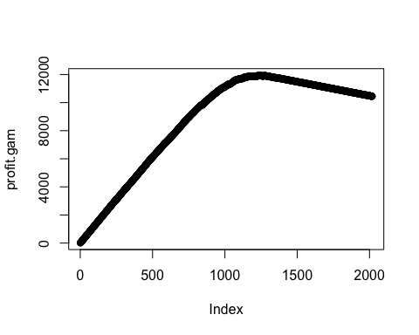

n.mail.valid <- which.max(profit.gam) # number of mailings that maximizes profits  
c(n.mail.valid, max(profit.gam)) # report number of mailings and maximum profit

## [1] 1237 11939  
  
cutoff.gam <- sort(post.valid.gam, decreasing=T)[n.mail.valid+1]

chat.valid.gam <- ifelse(post.valid.gam>cutoff.gam, 1, 0) # mail to everyone above the cutoff  
table(chat.valid.gam, c.valid) # classification table

# c.valid  
#chat.valid.gam 0 1  
# 0 776 5  
# 1 243 994  
# check n.mail.valid = 243+994 = 1237  
# check profit = 14.5*994-2*1237 = 11939

#### Model 6: Regression Tree

library(tree)  
tree.charity =tree(donr ~ reg1 + reg2 + reg3 + reg4 + home + chld + hinc + I(hinc^2) + genf + wrat + avhv + incm + inca + plow + npro + tgif + lgif + rgif + tdon + tlag + agif ,data.train.std.c)  
summary(tree.charity)  
## Regression tree:  
## tree(formula = donr ~ reg1 + reg2 + reg3 + reg4 + home + chld +   
## hinc + I(hinc^2) + genf + wrat + avhv + incm + inca + plow +   
## npro + tgif + lgif + rgif + tdon + tlag + agif, data = data.train.std.c)  
## Variables actually used in tree construction:  
## [1] "chld" "home" "I(hinc^2)" "reg2" "wrat" "tlag"   
## [7] "tdon"   
## Number of terminal nodes: 14   
## Residual mean deviance: 0.1088 = 431.8 / 3970   
## Distribution of residuals:  
## Min. 1st Qu. Median Mean 3rd Qu. Max.   
## -0.92720 -0.05339 0.07277 0.00000 0.07277 0.97560

plot(tree.charity); text(tree.charity ,pretty=0)

tree.pred <- predict (tree.charity ,data.valid.std.c)  
profit.tree <- cumsum(14.5*c.valid[order(tree.pred, decreasing=T)]-2)  
plot(profit.tree) # see how profits change as more mailings are made

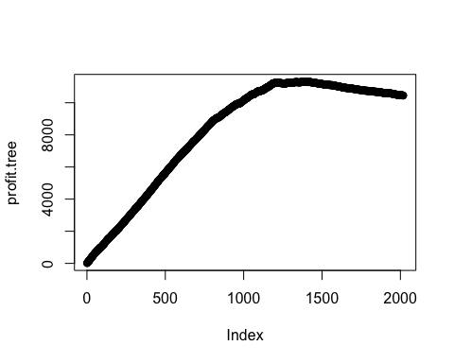

n.mail.valid <- which.max(profit.tree) # number of mailings that maximizes profits  
c(n.mail.valid, max(profit.tree)) # report number of mailings and maximum profit

## [1] 1391 11312  
  
cutoff.tree <- sort(tree.pred, decreasing=T)[n.mail.valid+1] # set cutoff based on n.mail.valid  
chat.valid.tree <- ifelse(tree.pred>cutoff.tree, 1, 0) # mail to everyone above the cutoff  
table(chat.valid.tree, c.valid) # classification table

# c.valid  
#chat.valid.tree 0 1  
# 0 645 37  
# 1 374 962  
# check: 374+962 = 1336  
# check: 14.5*962 - 2*1336 = 11277

#### 

#### Model 7: Random forest (RF)

library(randomForest); set.seed(1)

model.rf <- randomForest(donr ~ reg1 + reg2 + reg3 + reg4 + home + chld + hinc + I(hinc^2) + genf + wrat + avhv + npro + rgif + tdon + tlag, data.train.std.c, importance=TRUE)

importance(model.rf) # chld, home, reg2, wrat are among the most influence factors.

## %IncMSE IncNodePurity  
## reg1 27.9991851 15.474573  
## reg2 105.8628435 70.787351  
## reg3 10.7852658 6.619042  
## reg4 8.8438649 5.420146  
## home 120.8442012 66.621204  
## chld 281.3790597 295.296690  
## hinc 21.0531978 28.922596  
## I(hinc^2) 74.3146838 102.607126  
## genf -0.8239311 7.022072  
## wrat 84.7129643 70.799193  
## avhv 18.1592399 63.163948  
## npro 24.9536369 62.323803  
## rgif 2.3211371 40.715840  
## tdon 46.6740572 60.266954  
## tlag 33.6730735 44.637939

post.valid.rf <- predict(model.rf, data.valid.std.c) # n.valid post probs  
  
# calculate ordered profit function using average donation = $14.50 and mailing cost = $2  
profit.rf <- cumsum(14.5*c.valid[order(post.valid.rf, decreasing=T)]-2)  
plot(profit.rf) # see how profits change as more mailings are made

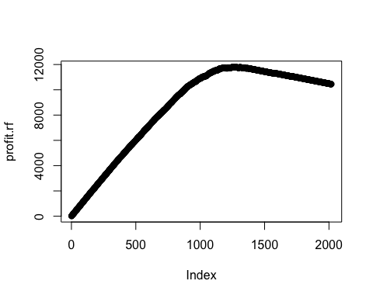

n.mail.valid <- which.max(profit.rf) # number of mailings that maximizes profits  
c(n.mail.valid, max(profit.rf)) # report number of mailings and maximum profit; 1256, 11799.5

## [1] 1256.0 11799.5

cutoff.rf <- sort(post.valid.rf, decreasing=T)[n.mail.valid+1] # set cutoff based on n.mail.valid  
chat.valid.rf <- ifelse(post.valid.rf > cutoff.rf, 1, 0) # mail to everyone above the cutoff  
table(chat.valid.rf, c.valid) # classification table

# c.valid  
#chat.valid.rf 0 1  
# 0 750 12  
# 1 269 987  
# check n.mail.valid = 269+987 = 1256  
# check profit = 14.5*987-2*1256 = 11799.5

#### 

#### Model 8: Support Vector Machine (SVM)

library(e1071)  
svm.charity <- svm(donr ~ reg1 + reg2 + reg3 + reg4 + home + chld + hinc + I(hinc^2) + genf + wrat + avhv + incm + inca + plow + npro + tgif + lgif + rgif + tdon + tlag + agif, data=data.train.std.c, kernel="linear",cost=10)

summary(svm.charity)  
## Call:  
## svm(formula = donr ~ reg1 + reg2 + reg3 + reg4 + home + chld +   
## hinc + I(hinc^2) + genf + wrat + avhv + incm + inca + plow +   
## npro + tgif + lgif + rgif + tdon + tlag + agif, data = data.train.std.c,   
## kernel = "linear", cost = 10)  
##   
##   
## Parameters:  
## SVM-Type: eps-regression   
## SVM-Kernel: linear   
## cost: 10   
## gamma: 0.04761905   
## epsilon: 0.1   
##   
##   
## Number of Support Vectors: 3527

svm.pred <- predict (svm.charity ,data.valid.std.c)  
profit.svm <- cumsum(14.5*c.valid[order(svm.pred, decreasing=T)]-2)  
plot(profit.svm) # see how profits change as more mailings are made

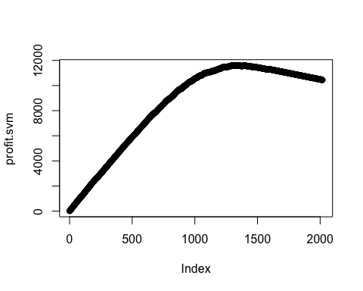

n.mail.valid <- which.max(profit.svm) # number of mailings that maximizes profits  
c(n.mail.valid, max(profit.svm)) # report number of mailings and maximum profit

## [1] 1314.0 11596.5  
  
cutoff.svm <- sort(svm.pred, decreasing=T)[n.mail.valid+1] # set cutoff based on n.mail.valid  
chat.valid.svm <- ifelse(svm.pred>cutoff.svm, 1, 0) # mail to everyone above the cutoff  
table(chat.valid.svm, c.valid) # classification table

# c.valid  
#chat.valid.svm 0 1  
# 0 686 18  
# 1 333 981  
# Check 333+981 = 1314  
# Check 14.5*981 - 2*1314 = 11596.5

### Prediction modeling

#### Model 1: Least squares regression

model.ls <- lm(damt ~ reg1 + reg2 + reg3 + reg4 + home + chld + hinc + I(hinc^2) + genf + wrat + avhv + npro + rgif + tdon + tlag, data.train.std.y)  
summary(model.ls) # we can see some predictors are not significant; so I drop them (reg1, reg2, wrat and tlag); also note that the predictor error and std error will not change much after dropping them

##   
## Call:  
## lm(formula = damt ~ reg1 + reg2 + reg3 + reg4 + home + chld +   
## hinc + I(hinc^2) + genf + wrat + avhv + npro + rgif + tdon +   
## tlag, data = data.train.std.y)  
##   
## Residuals:  
## Min 1Q Median 3Q Max   
## -3.1922 -0.8254 -0.1987 0.6055 9.6137   
##   
## Coefficients:  
## Estimate Std. Error t value Pr(>|t|)   
## (Intercept) 14.23009 0.04664 305.092 < 2e-16 ***  
## reg1 -0.04762 0.03935 -1.210 0.22632   
## reg2 -0.08167 0.04312 -1.894 0.05838 .   
## reg3 0.32672 0.04010 8.148 6.48e-16 ***  
## reg4 0.63190 0.04124 15.324 < 2e-16 ***  
## home 0.25206 0.06076 4.149 3.48e-05 ***  
## chld -0.59628 0.03921 -15.209 < 2e-16 ***  
## hinc 0.50312 0.03964 12.692 < 2e-16 ***  
## I(hinc^2) -0.05300 0.02946 -1.799 0.07215 .   
## genf -0.06498 0.02833 -2.293 0.02193 *   
## wrat 0.01691 0.04139 0.409 0.68286   
## avhv 0.06684 0.02889 2.313 0.02080 *   
## npro 0.16860 0.02874 5.867 5.19e-09 ***  
## rgif 1.11487 0.02824 39.484 < 2e-16 ***  
## tdon 0.09491 0.03472 2.733 0.00633 **   
## tlag 0.03497 0.03079 1.136 0.25618   
## ---  
## Signif. codes: 0 '***' 0.001 '**' 0.01 '*' 0.05 '.' 0.1 ' ' 1  
##   
## Residual standard error: 1.267 on 1979 degrees of freedom  
## Multiple R-squared: 0.5753, Adjusted R-squared: 0.5721   
## F-statistic: 178.7 on 15 and 1979 DF, p-value: < 2.2e-16

model.ls <- lm(damt ~ reg3 + reg4 + home + chld + hinc + I(hinc^2) + genf + avhv + npro + rgif + tdon, data.train.std.y)  
summary(model.ls)

##   
## Call:  
## lm(formula = damt ~ reg3 + reg4 + home + chld + hinc + I(hinc^2) +   
## genf + avhv + npro + rgif + tdon, data = data.train.std.y)  
##   
## Residuals:  
## Min 1Q Median 3Q Max   
## -3.2823 -0.8212 -0.1829 0.6087 9.5277   
##   
## Coefficients:  
## Estimate Std. Error t value Pr(>|t|)   
## (Intercept) 14.20454 0.04221 336.551 < 2e-16 ***  
## reg3 0.36560 0.03341 10.942 < 2e-16 ***  
## reg4 0.67162 0.03431 19.574 < 2e-16 ***  
## home 0.26788 0.06025 4.446 9.24e-06 ***  
## chld -0.61768 0.03700 -16.694 < 2e-16 ***  
## hinc 0.50324 0.03954 12.727 < 2e-16 ***  
## I(hinc^2) -0.06439 0.02882 -2.234 0.02558 *   
## genf -0.06545 0.02833 -2.310 0.02099 *   
## avhv 0.06883 0.02875 2.394 0.01675 *   
## npro 0.17356 0.02861 6.067 1.56e-09 ***  
## rgif 1.11448 0.02824 39.465 < 2e-16 ***  
## tdon 0.09481 0.03473 2.730 0.00638 **   
## ---  
## Signif. codes: 0 '***' 0.001 '**' 0.01 '*' 0.05 '.' 0.1 ' ' 1  
##   
## Residual standard error: 1.267 on 1983 degrees of freedom  
## Multiple R-squared: 0.5742, Adjusted R-squared: 0.5719   
## F-statistic: 243.1 on 11 and 1983 DF, p-value: < 2.2e-16

pred.valid.ls <- predict(model.ls, data.valid.std.y) # validation predictions  
mean((y.valid - pred.valid.ls)^2) # mean prediction error

## [1] 1.880341

sd((y.valid - pred.valid.ls)^2)/sqrt(n.valid.y) # std error

## [1] 0.1694115

# Check assumptions  
par(mfrow=c(2,2)); plot(model.ls)

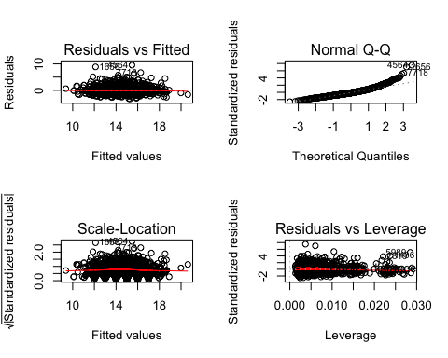

library(car); vif(model.ls)

## reg3 reg4 home chld hinc I(hinc^2) genf   
## 1.041498 1.045173 1.027610 1.142138 1.004954 1.083112 1.004724   
## avhv npro rgif tdon   
## 1.026368 1.020440 1.003911 1.007183

# all ok around 1 - multicollinearity not an issue

#### Model 2: Stepwise regression using AIC

library(MASS)  
model.AIC <- lm(damt ~ reg1 + reg2 + reg3 + reg4 + home + chld + hinc + I(hinc^2) + genf + wrat + avhv + npro + rgif + tdon + tlag, data.train.std.y)  
step <- stepAIC(model.AIC, direction="both")

step$anova # note that the model with smallest AIC is exactly the same as model 1

summary(step)

##   
## Call:  
## lm(formula = damt ~ reg2 + reg3 + reg4 + home + chld + hinc +   
## I(hinc^2) + genf + avhv + npro + rgif + tdon, data = data.train.std.y)  
##   
## Residuals:  
## Min 1Q Median 3Q Max   
## -3.2263 -0.8147 -0.1903 0.6028 9.5868   
##   
## Coefficients:  
## Estimate Std. Error t value Pr(>|t|)   
## (Intercept) 14.21978 0.04354 326.610 < 2e-16 ***  
## reg2 -0.04429 0.03117 -1.421 0.15549   
## reg3 0.35091 0.03497 10.035 < 2e-16 ***  
## reg4 0.65658 0.03590 18.291 < 2e-16 ***  
## home 0.25880 0.06058 4.272 2.03e-05 ***  
## chld -0.60302 0.03840 -15.703 < 2e-16 ***  
## hinc 0.50505 0.03955 12.769 < 2e-16 ***  
## I(hinc^2) -0.05790 0.02917 -1.985 0.04730 *   
## genf -0.06474 0.02833 -2.285 0.02240 *   
## avhv 0.06591 0.02881 2.288 0.02226 *   
## npro 0.17017 0.02870 5.929 3.58e-09 ***  
## rgif 1.11447 0.02823 39.475 < 2e-16 ***  
## tdon 0.09413 0.03472 2.711 0.00676 **   
## ---  
## Signif. codes: 0 '***' 0.001 '**' 0.01 '*' 0.05 '.' 0.1 ' ' 1  
##   
## Residual standard error: 1.267 on 1982 degrees of freedom  
## Multiple R-squared: 0.5747, Adjusted R-squared: 0.5721   
## F-statistic: 223.1 on 12 and 1982 DF, p-value: < 2.2e-16

model.AIC <- lm(damt ~ reg2 + reg3 + reg4 + home + chld + hinc + I(hinc^2) + genf + avhv + npro + rgif + tdon, data.train.std.y)  
summary(model.AIC)

##   
## Call:  
## lm(formula = damt ~ reg2 + reg3 + reg4 + home + chld + hinc +   
## I(hinc^2) + genf + avhv + npro + rgif + tdon, data = data.train.std.y)  
##   
## Residuals:  
## Min 1Q Median 3Q Max   
## -3.2263 -0.8147 -0.1903 0.6028 9.5868   
##   
## Coefficients:  
## Estimate Std. Error t value Pr(>|t|)   
## (Intercept) 14.21978 0.04354 326.610 < 2e-16 ***  
## reg2 -0.04429 0.03117 -1.421 0.15549   
## reg3 0.35091 0.03497 10.035 < 2e-16 ***  
## reg4 0.65658 0.03590 18.291 < 2e-16 ***  
## home 0.25880 0.06058 4.272 2.03e-05 ***  
## chld -0.60302 0.03840 -15.703 < 2e-16 ***  
## hinc 0.50505 0.03955 12.769 < 2e-16 ***  
## I(hinc^2) -0.05790 0.02917 -1.985 0.04730 *   
## genf -0.06474 0.02833 -2.285 0.02240 *   
## avhv 0.06591 0.02881 2.288 0.02226 *   
## npro 0.17017 0.02870 5.929 3.58e-09 ***  
## rgif 1.11447 0.02823 39.475 < 2e-16 ***  
## tdon 0.09413 0.03472 2.711 0.00676 **   
## ---  
## Signif. codes: 0 '***' 0.001 '**' 0.01 '*' 0.05 '.' 0.1 ' ' 1  
##   
## Residual standard error: 1.267 on 1982 degrees of freedom  
## Multiple R-squared: 0.5747, Adjusted R-squared: 0.5721   
## F-statistic: 223.1 on 12 and 1982 DF, p-value: < 2.2e-16

pred.valid.aic <- predict(model.AIC, data.valid.std.y) # validation predictions  
mean((y.valid - pred.valid.aic)^2) # mean prediction error

## [1] 1.871926

sd((y.valid - pred.valid.aic)^2)/sqrt(n.valid.y) # std error

## [1] 0.1687491

# Check assumptions  
par(mfrow=c(2,2)); plot(model.AIC)

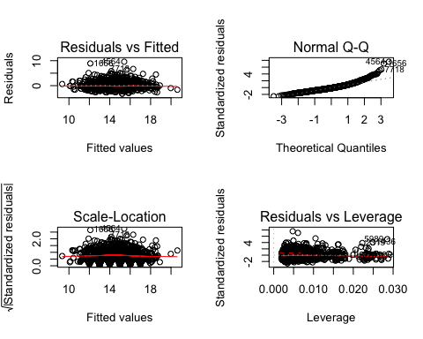

library(car); vif(model.AIC)

## reg2 reg3 reg4 home chld hinc I(hinc^2)   
## 1.341120 1.141290 1.144626 1.039159 1.230919 1.005995 1.110321   
## genf avhv npro rgif tdon   
## 1.005032 1.031588 1.027540 1.003911 1.007373

# all ok around 1 - multicollinearity not an issue

#### 

#### Model 3: Best subset selection using BIC

library(leaps)  
BIC <- regsubsets(damt ~ reg1 + reg2 + reg3 + reg4 + home + chld + hinc + I(hinc^2) + genf + wrat + avhv + npro + rgif + tdon + tlag, data.train.std.y, nvmax=10)

summary(BIC)

## Subset selection object  
## Call: regsubsets.formula(damt ~ reg1 + reg2 + reg3 + reg4 + home +   
## chld + hinc + I(hinc^2) + genf + wrat + avhv + npro + rgif +   
## tdon + tlag, data.train.std.y, nvmax = 10)  
## 15 Variables (and intercept)  
## Forced in Forced out  
## reg1 FALSE FALSE  
## reg2 FALSE FALSE  
## reg3 FALSE FALSE  
## reg4 FALSE FALSE  
## home FALSE FALSE  
## chld FALSE FALSE  
## hinc FALSE FALSE  
## I(hinc^2) FALSE FALSE  
## genf FALSE FALSE  
## wrat FALSE FALSE  
## avhv FALSE FALSE  
## npro FALSE FALSE  
## rgif FALSE FALSE  
## tdon FALSE FALSE  
## tlag FALSE FALSE  
## 1 subsets of each size up to 10  
## Selection Algorithm: exhaustive  
## reg1 reg2 reg3 reg4 home chld hinc I(hinc^2) genf wrat avhv npro  
## 1 ( 1 ) " " " " " " " " " " " " " " " " " " " " " " " "   
## 2 ( 1 ) " " " " " " "*" " " " " " " " " " " " " " " " "   
## 3 ( 1 ) " " " " " " "*" " " "*" " " " " " " " " " " " "   
## 4 ( 1 ) " " " " " " "*" " " "*" "*" " " " " " " " " " "   
## 5 ( 1 ) " " " " "*" "*" " " "*" "*" " " " " " " " " " "   
## 6 ( 1 ) " " " " "*" "*" " " "*" "*" " " " " " " " " "*"   
## 7 ( 1 ) " " " " "*" "*" "*" "*" "*" " " " " " " " " "*"   
## 8 ( 1 ) " " " " "*" "*" "*" "*" "*" " " " " " " " " "*"   
## 9 ( 1 ) " " " " "*" "*" "*" "*" "*" " " "*" " " " " "*"   
## 10 ( 1 ) " " " " "*" "*" "*" "*" "*" " " "*" " " "*" "*"   
## rgif tdon tlag  
## 1 ( 1 ) "*" " " " "   
## 2 ( 1 ) "*" " " " "   
## 3 ( 1 ) "*" " " " "   
## 4 ( 1 ) "*" " " " "   
## 5 ( 1 ) "*" " " " "   
## 6 ( 1 ) "*" " " " "   
## 7 ( 1 ) "*" " " " "   
## 8 ( 1 ) "*" "*" " "   
## 9 ( 1 ) "*" "*" " "   
## 10 ( 1 ) "*" "*" " "

# determine the number of variables with the lowest BIC value

which.min(summary(BIC)$bic)

## [1] 8

coef(BIC, id=8)

## (Intercept) reg3 reg4 home chld hinc   
## 14.2031999 0.3767497 0.6793971 0.2554029 -0.5890471 0.4973662   
## npro rgif tdon   
## 0.1666014 1.1119596 0.0977098

# Create the function to use predict() with regsubsets   
predict.regsubsets=function(object,newdata,id,...){  
 form=as.formula(object$call[[2]])  
 mat=model.matrix(form,newdata)  
 coefi=coef(object,id=id)  
 xvars=names(coefi)  
 mat[,xvars]%*%coefi  
}  
  
pred.BIC <- predict(BIC, data.valid.std.y, id=8) # validation predictions   
mean((y.valid-pred.BIC)^2) # mean prediction error 1.895

## [1] 1.895405

sd((y.valid-pred.BIC)^2)/sqrt(n.valid.y) # std error 0.170

## [1] 0.1697195

plot(BIC, scale='bic')

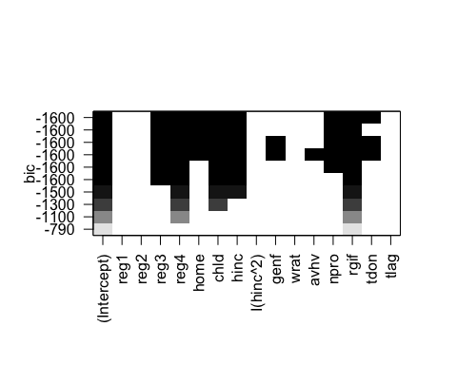

#### Model 4: Ridge regression using 10-fold cross-validation

library(glmnet) # The package "glmnet" was used to perform Ridge Regression and Lasso

set.seed(2015)   
x <- as.matrix(data.train.std.y[,1:20]); y <- as.matrix(data.train.std.y[,21])  
valid.x <- as.matrix(data.valid.std.y[,1:20])   
valid.y <- as.matrix(data.valid.std.y[,21])  
cv.out <- cv.glmnet(x, y, alpha=0, nfolds=10)  
bestlambda <- cv.out$lambda.1se; bestlambda

## [1] 0.7873924

ridge <- glmnet(x, y, alpha=0)   
pred.ridge <- predict(ridge, s=bestlambda, valid.x)  
mean((valid.y-pred.ridge)^2) # mean prediction error 1.832

## [1] 1.832544

sd((valid.y-pred.ridge)^2)/sqrt(n.valid.y) # std error 0.173

## [1] 0.1728453

plot(cv.out)

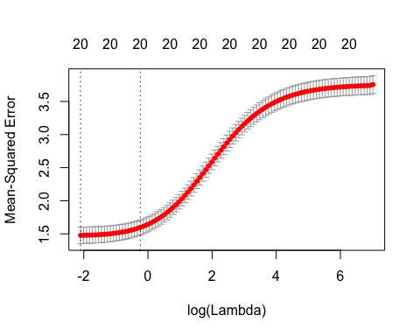

#### 

#### Model 5: Lasso regression using 10-fold cross-validation

set.seed(2015)  
cv.out <- cv.glmnet(x, y, alpha=1, nfolds=10)  
bestlambda <- cv.out$lambda.1se; bestlambda

## [1] 0.09935765

lasso <- glmnet(x, y, alpha=1)  
pred.lasso <- predict(lasso, s=bestlambda, valid.x, exact=T)   
mean((valid.y-pred.lasso)^2) # mean prediction error 1.819

## [1] 1.819467

sd((valid.y-pred.lasso)^2)/sqrt(n.valid.y) # std error 0.164

## [1] 0.1641376

plot(cv.out)

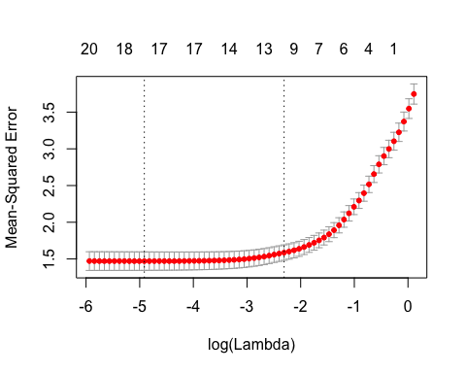

#### 

#### Model 6: Principal Components Regression

library(pls)

set.seed(2015)  
pcr.fit=pcr(damt ~ reg1 + reg2 + reg3 + reg4 + home + chld + hinc + I(hinc^2) + genf + wrat + avhv + npro + rgif + tdon + tlag, data=data.train.std.y, validation="CV")

summary(pcr.fit)

## Data: X dimension: 1995 15   
## Y dimension: 1995 1  
## Fit method: svdpc  
## Number of components considered: 15  
##   
## VALIDATION: RMSEP  
## Cross-validated using 10 random segments.  
## (Intercept) 1 comps 2 comps 3 comps 4 comps 5 comps 6 comps  
## CV 1.937 1.908 1.873 1.813 1.726 1.669 1.624  
## adjCV 1.937 1.907 1.876 1.839 1.706 1.675 1.651  
## 7 comps 8 comps 9 comps 10 comps 11 comps 12 comps 13 comps  
## CV 1.370 1.361 1.345 1.342 1.327 1.304 1.293  
## adjCV 1.362 1.358 1.344 1.342 1.327 1.304 1.293  
## 14 comps 15 comps  
## CV 1.293 1.275  
## adjCV 1.293 1.274  
##   
## TRAINING: % variance explained  
## 1 comps 2 comps 3 comps 4 comps 5 comps 6 comps 7 comps  
## X 14.045 23.700 32.45 41.1 49.57 57.68 65.51  
## damt 2.994 6.525 11.45 23.8 26.38 28.90 50.82  
## 8 comps 9 comps 10 comps 11 comps 12 comps 13 comps 14 comps  
## X 72.68 79.26 84.78 89.24 93.42 96.75 98.54  
## damt 51.18 52.40 52.67 53.89 55.40 56.19 56.25  
## 15 comps  
## X 100.00  
## damt 57.53

pred.valid.pcr <- predict(pcr.fit, data.valid.std.y,ncomp=15)  
mean((y.valid - pred.valid.pcr)^2) # mean prediction error

## [1] 1.869997

sd((y.valid - pred.valid.pcr)^2)/sqrt(n.valid.y) # std error

## [1] 0.1689471

#### 

#### Model 7: Partial Least Squares

set.seed(2015)  
pls.fit=plsr(damt ~ reg1 + reg2 + reg3 + reg4 + home + chld + hinc + I(hinc^2) + genf + wrat + avhv + npro + rgif + tdon + tlag, data=data.train.std.y, validation="CV")

summary(pls.fit)

## Data: X dimension: 1995 15   
## Y dimension: 1995 1  
## Fit method: kernelpls  
## Number of components considered: 15  
##   
## VALIDATION: RMSEP  
## Cross-validated using 10 random segments.  
## (Intercept) 1 comps 2 comps 3 comps 4 comps 5 comps 6 comps  
## CV 1.937 1.322 1.289 1.280 1.277 1.275 1.275  
## adjCV 1.937 1.321 1.289 1.279 1.276 1.274 1.274  
## 7 comps 8 comps 9 comps 10 comps 11 comps 12 comps 13 comps  
## CV 1.275 1.275 1.275 1.275 1.275 1.275 1.275  
## adjCV 1.274 1.274 1.274 1.274 1.274 1.274 1.274  
## 14 comps 15 comps  
## CV 1.275 1.275  
## adjCV 1.274 1.274  
##   
## TRAINING: % variance explained  
## 1 comps 2 comps 3 comps 4 comps 5 comps 6 comps 7 comps  
## X 9.113 21.22 27.07 33.35 37.72 44.60 50.08  
## damt 54.082 56.40 57.19 57.41 57.51 57.53 57.53  
## 8 comps 9 comps 10 comps 11 comps 12 comps 13 comps 14 comps  
## X 55.65 59.89 65.15 71.39 77.21 84.00 91.64  
## damt 57.53 57.53 57.53 57.53 57.53 57.53 57.53  
## 15 comps  
## X 100.00  
## damt 57.53

pred.valid.pls <- predict(pls.fit, data.valid.std.y,ncomp=5)  
mean((y.valid - pred.valid.pls)^2) # mean prediction error

## [1] 1.873125

sd((y.valid - pred.valid.pls)^2)/sqrt(n.valid.y) # std error

## [1] 0.1693118